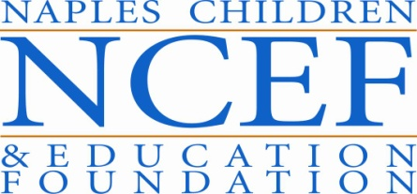 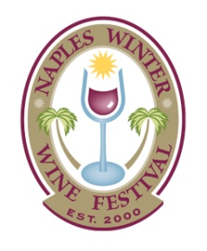

**4305 Exchange Avenue**

**Naples, Florida 34104**

To: Interested Graphic Design Service Providers

Date: February 4, 2015

Re: **Request for Proposal –Graphic Design of Marketing Communications Materials 2016**

The Naples Children & Education Foundation (NCEF), founders of the Naples Winter Wine Festival (NWWF), seeks professional graphic design services.

Background: The Naples Children & Education Foundation supports effective, disciplined charitable programs that significantly improve the physical, emotional and educational lives of underprivileged and at-risk children in Collier County, Florida. NCEF operates through a grant making process in which needs are identified, and a rigorous vetting process awards charities funds raised each year through the Naples Winter Wine Festival. These grants are awarded to 501(c)3 organizations that help fulfill children’s needs for food, shelter, healthcare, education and other special requirements.

Since its founding in 2000, NCEF has raised over $135 million, funding over 40 beneficiary organizations and seven strategic initiatives helping to provide a better life for about 200,000 children. Through NCEF funding, nearly 2.5 million meals have been served to the hungry. In addition, health, dental health and vision services that were previously unavailable are now reality.

We seek professional graphic design services to generate and produce the marketing communications materials for the 2016 Naples Winter Wine Festival. This includes: creative concept development, copywriting of all items (excluding auction lots), design and layout, production management, proofreading, revisions, digital file preparation and print management of the following items:

* **Naples Winter Wine Festival Materials** 
  + 2016 Festival Logo & Theme
  + Save the Date with Envelope/Packaging
  + Festival Invitation, RSVP and Envelope/Packaging
  + VIP Invitation with Envelope/Packaging
  + Special Event Invitation with Envelope/Packaging
  + Stamp Design for each invitation
  + T-Shirt Designs – Festival and Volunteers
  + Designs for Merchandising (hats, aprons, scarves, polo shirts and miscellaneous)
  + Stock Photography, Illustrations and Fonts for all printed materials
* **Auction Support Materials** 
  + Auction Catalog with Packaging and Stamp Design (paper clip or other marker for lots design)
  + Stock Photography, Illustrations and Fonts for all printed materials
  + At-a-Glance Auction Guide
  + Auction Signage (Vintners Signage, Sponsor Signage, etc.)
  + Auction Day Power Point Backgrounds
* **Meet the Kids Materials** 
  + Meet the Kids Day Invitation with Envelope/Packaging/Stamp
  + Meet the Kids Day Event Materials (posters, handouts, etc.)
  + Meet the Kids Day T-Shirt Design
* **Fund-a-Need Materials** 
  + Fund-a-Need Logo
  + Fund-a-Need Card Design
  + Fund-a-Need Prop Design
  + Fund-a-Need T-Shirt design
  + Fund-a-Need Handouts
* **Additional Printed Materials**
  + Cultivation Event Invitations and Packaging (and stamp design if needed)
  + Marketing Campaign Materials (ad campaigns or e-marketing materials)
  + Website Graphics (one major overhaul of site graphics with minor add-ons throughout the year)

Proposals may be submitted in hard copy to the Naples Children & Education Foundation, Attn: Lisa Juliano, at 4305 Exchange Avenue, Naples, Florida 34104 or electronically via pdf file to [lisa@napleswinefestival.com](mailto:lisa@napleswinefestival.com) by February 16, 2015.

Sincerely,

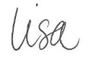

**Lisa Juliano**

**Deputy Director, Naples Winter Wine Festival**